Libya

## Freedom House political status

The data set shows the Freedom House political scores and status of the country each year.

## # A tibble: 19 x 5  
## country iso3c date mean status   
## <chr> <chr> <dbl> <dbl> <chr>   
## 1 Libya LBY 1996 7 Not Free   
## 2 Libya LBY 1998 7 Not Free   
## 3 Libya LBY 2000 7 Not Free   
## 4 Libya LBY 2002 7 Not Free   
## 5 Libya LBY 2003 7 Not Free   
## 6 Libya LBY 2004 7 Not Free   
## 7 Libya LBY 2005 7 Not Free   
## 8 Libya LBY 2006 7 Not Free   
## 9 Libya LBY 2007 7 Not Free   
## 10 Libya LBY 2008 7 Not Free   
## 11 Libya LBY 2009 7 Not Free   
## 12 Libya LBY 2010 7 Not Free   
## 13 Libya LBY 2011 6.5 Not Free   
## 14 Libya LBY 2012 4.5 Partly Free  
## 15 Libya LBY 2013 4.5 Partly Free  
## 16 Libya LBY 2014 6 Not Free   
## 17 Libya LBY 2015 6 Not Free   
## 18 Libya LBY 2016 6.5 Not Free   
## 19 Libya LBY 2017 6.5 Not Free

## Freedom House classification of political change

The data set shows the GDP growth and the ecomic growth classification of the country each year.

## # A tibble: 19 x 4  
## country iso3c date politicalChangeFH  
## <chr> <chr> <dbl> <chr>   
## 1 Libya LBY 1996 no change   
## 2 Libya LBY 1998 no change   
## 3 Libya LBY 2000 no change   
## 4 Libya LBY 2002 no change   
## 5 Libya LBY 2003 no change   
## 6 Libya LBY 2004 no change   
## 7 Libya LBY 2005 no change   
## 8 Libya LBY 2006 no change   
## 9 Libya LBY 2007 no change   
## 10 Libya LBY 2008 no change   
## 11 Libya LBY 2009 no change   
## 12 Libya LBY 2010 no change   
## 13 Libya LBY 2011 democratization   
## 14 Libya LBY 2012 democratization   
## 15 Libya LBY 2013 no change   
## 16 Libya LBY 2014 autocratization   
## 17 Libya LBY 2015 no change   
## 18 Libya LBY 2016 autocratization   
## 19 Libya LBY 2017 no change

## Freedom House score trend

The plot shows the Freedom House scores trend of the country.

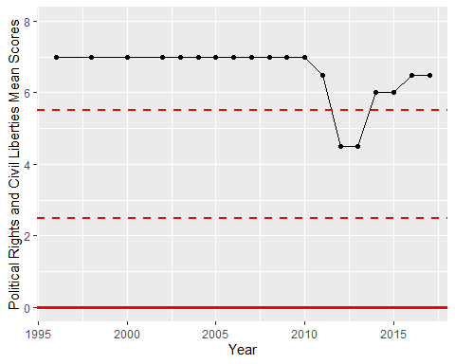

Freedom House Score Trend